Practice Questions

S.No. | Questions | BLT | CO
1. | Test the analyticity of the functions and find the derivative.  (i) 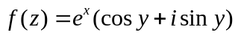 (ii) 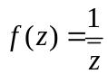 (iii)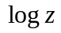 (iv) 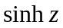 | K3 | 4
2. | Show that the function defined by f (z) = 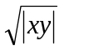is not regular at the origin although C-R equations are satisfied there. | K3 | 4
3. | Show that the function 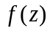defined by 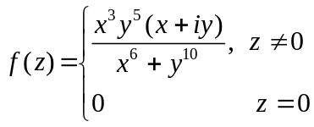 is not analytic at the  origin even though it satisfies Cauchy-Riemann equation at the origin. | K3 | 4
4. | Show that the function defined by 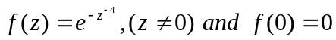is not analytic, although Cauchy-Riemann equations are satisfied at the point. | K3 | 4
5. | Construct an analytic function whose real part u(x, y) is:  - e^{x} (x cosy- y siny) (ii) 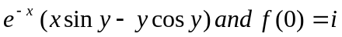 | K3 | 4
6. | Construct an analytic function whose imaginary part v(x, y) is:  (i) 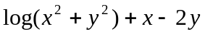 (ii) 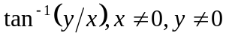 (iii) 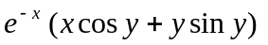 | K3 | 4
7. | Determine the analytic functions f(z)= u+iv such that u+v = e^{x}(cosy - siny) | K3 | 4
8. | If 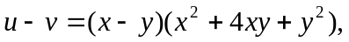then find an analytic function f(z) = u + iv in terms of z. | K3 | 4
9. | If 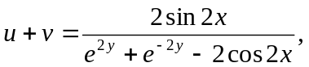then find an analytic function f(z) = u + iv in terms of z. | K3 | 4
10. | Find the Bilinear transformation which maps the points 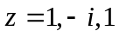to the points 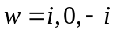 respectively. Show also that transformation maps the region outside the circle 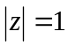 into the half-plane 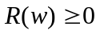 | K3 | 4
11. | Find the bilinear transformation which maps the points 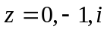onto 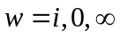. Also  find the image of the unit circle | K3 | 4
12. | Find the bilinear transformation which maps the points 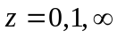onto 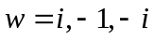. | K3 | 4
13. | Obtain the invariant points of the transformation (i)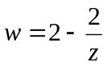 (ii) 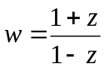 | K3 | 4
14. | Obtain the fixed points of the transformation (i)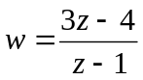 (ii) 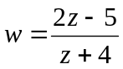 | K3 | 4
15. | State Cauchy Integral Theorem and hence evaluate: Evaluate 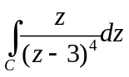where C is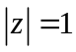. | K3 | 5
16. | Evaluate 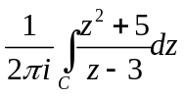where C is 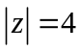. | K3 | 5
17. | Using Cauchy’s integral formula, evaluate the following integrals:  (i)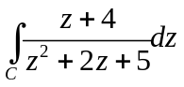where C is the circle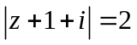. (ii)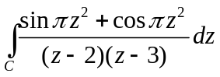 where C is. (iii) 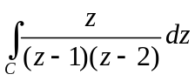 where C is the circle 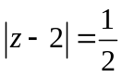. | K3 | 5
18. | Evaluate: (i).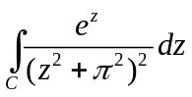 where C is the circle.  - 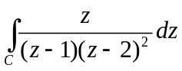 where C is the circle | K3 | 5

